**Time Series Analysis in Python | Time Series Forecasting | Data Science with Python | Edureka**

**eureka!** channel

<https://www.youtube.com/watch?v=e8Yw4alG16Q>

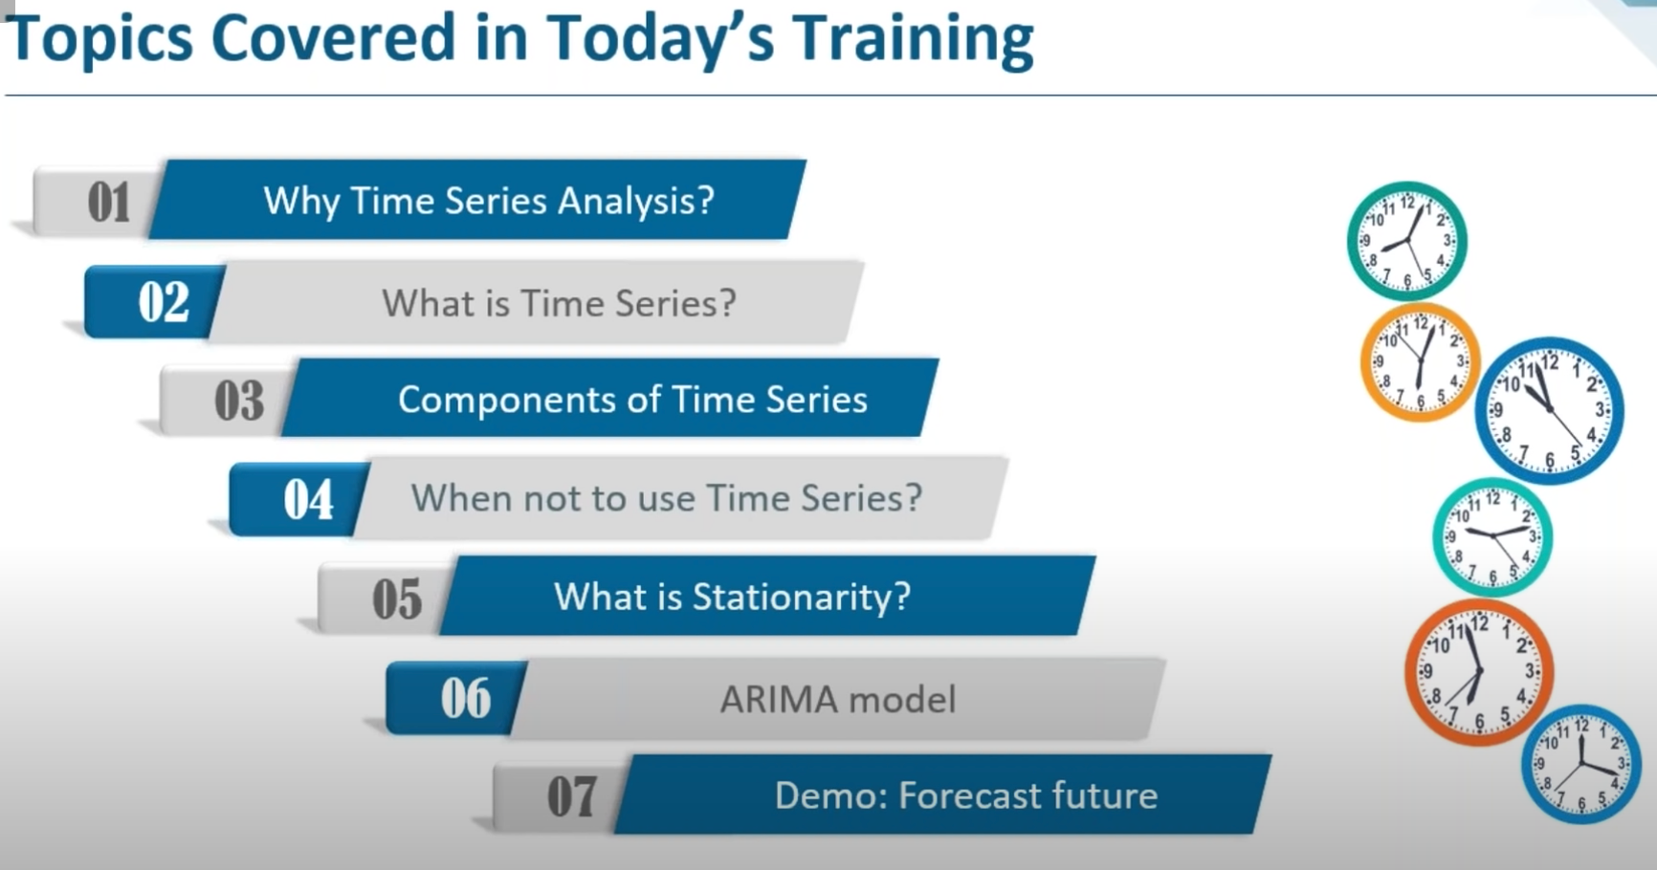

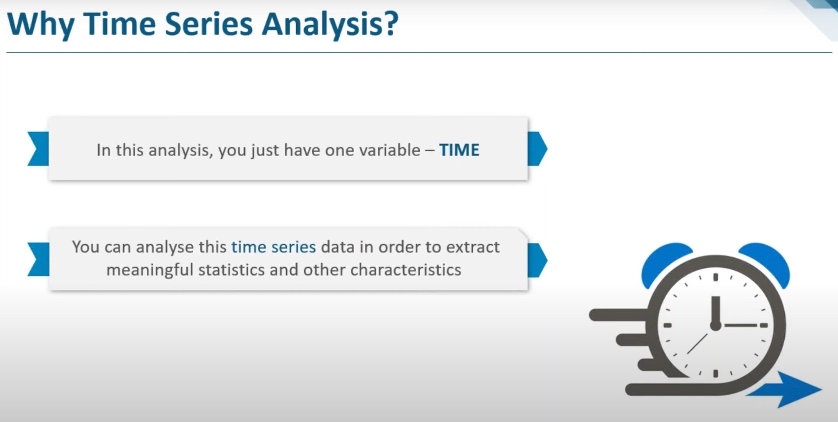

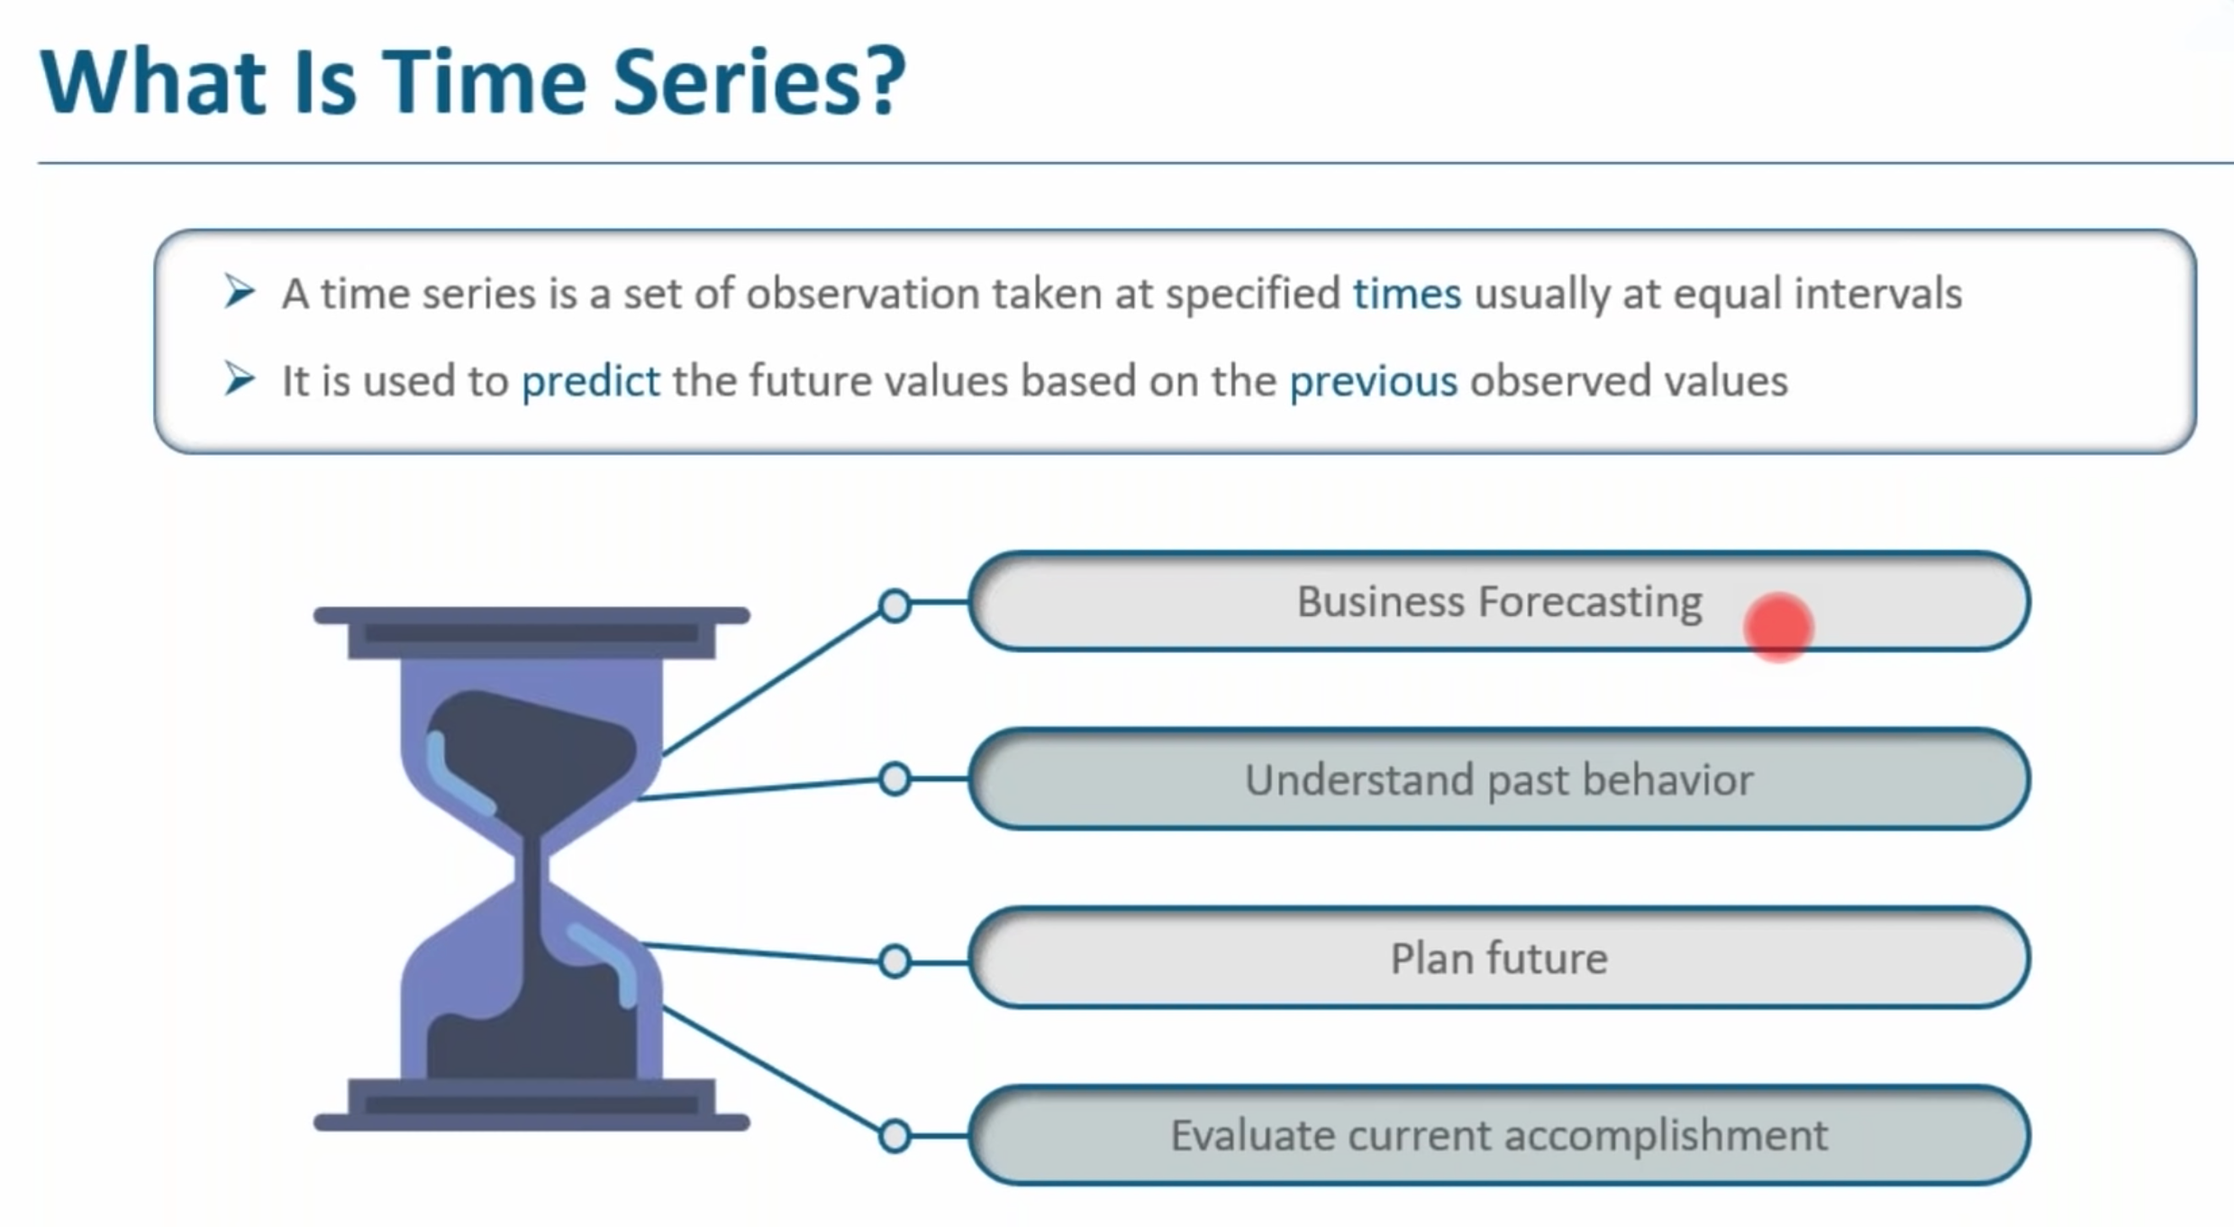

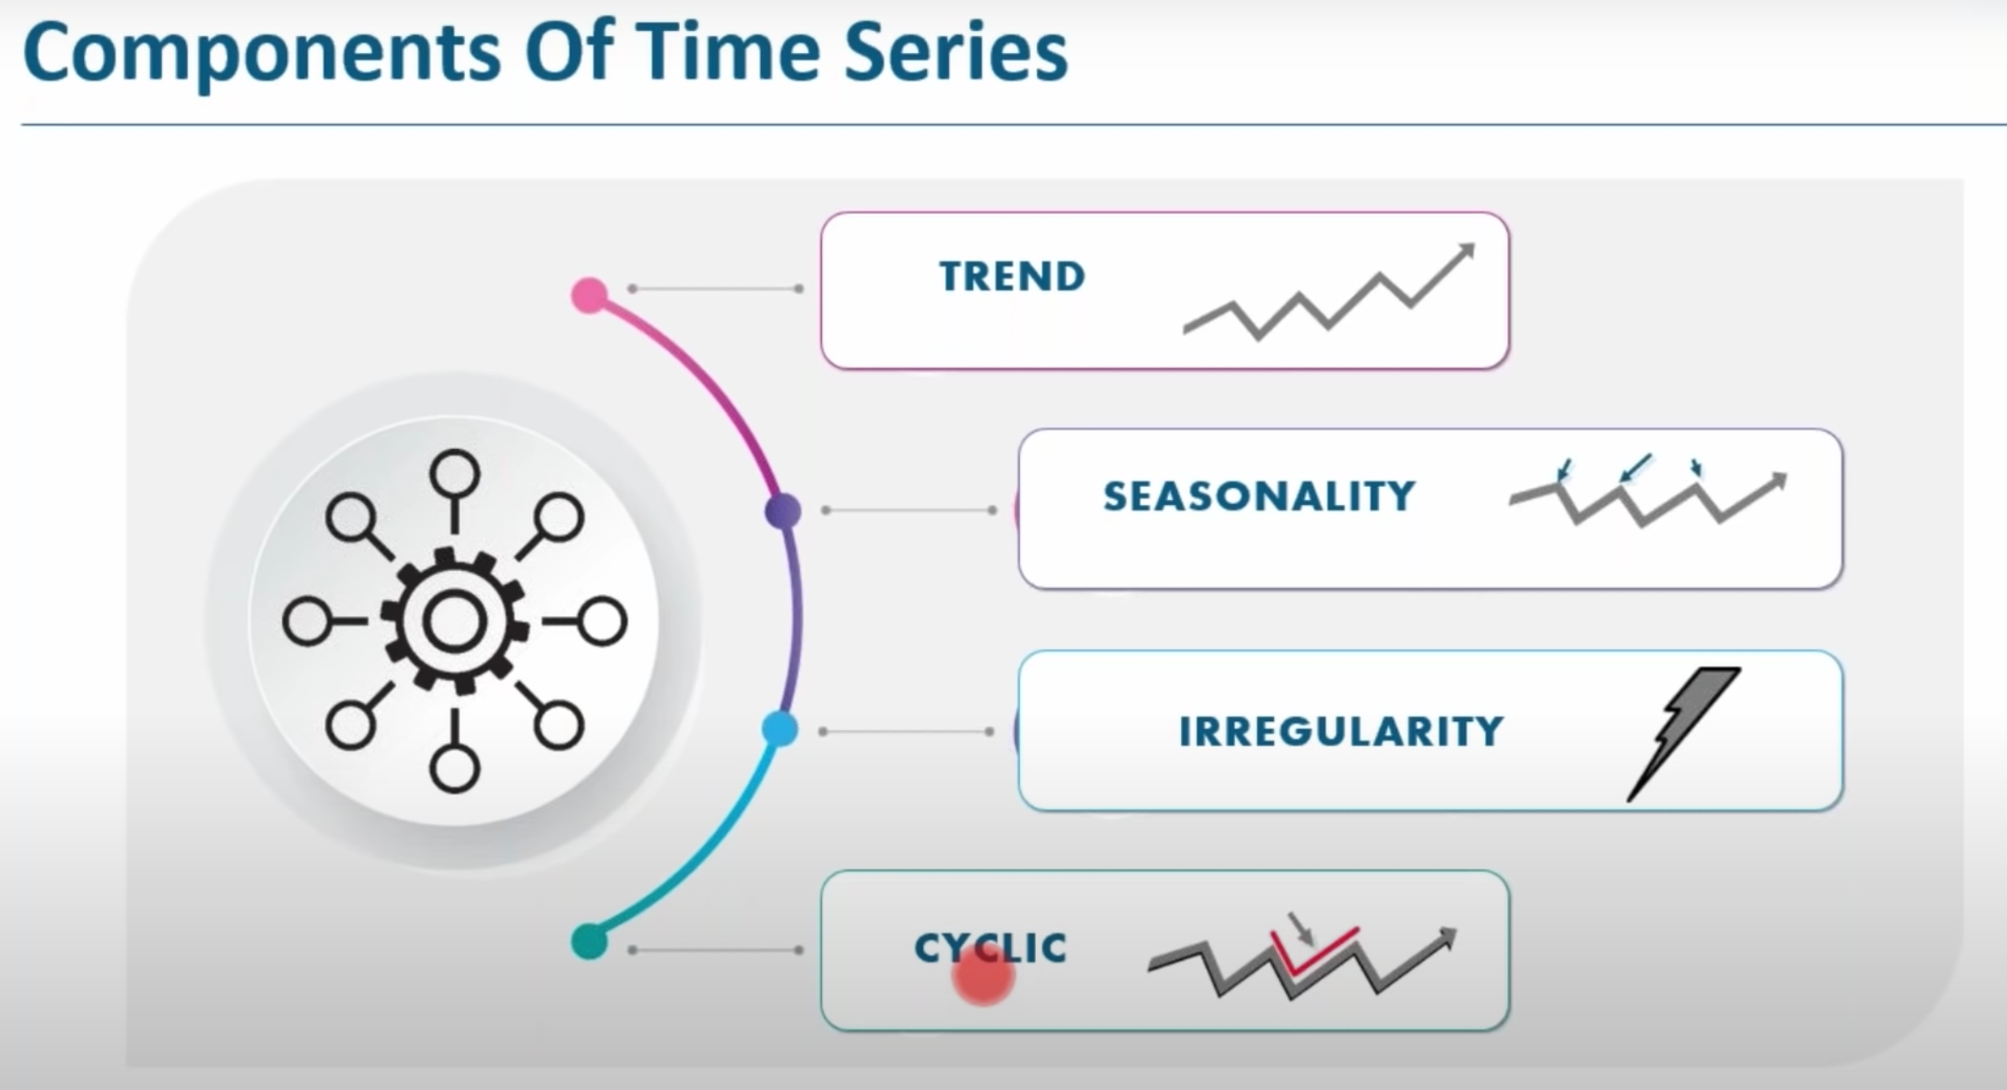

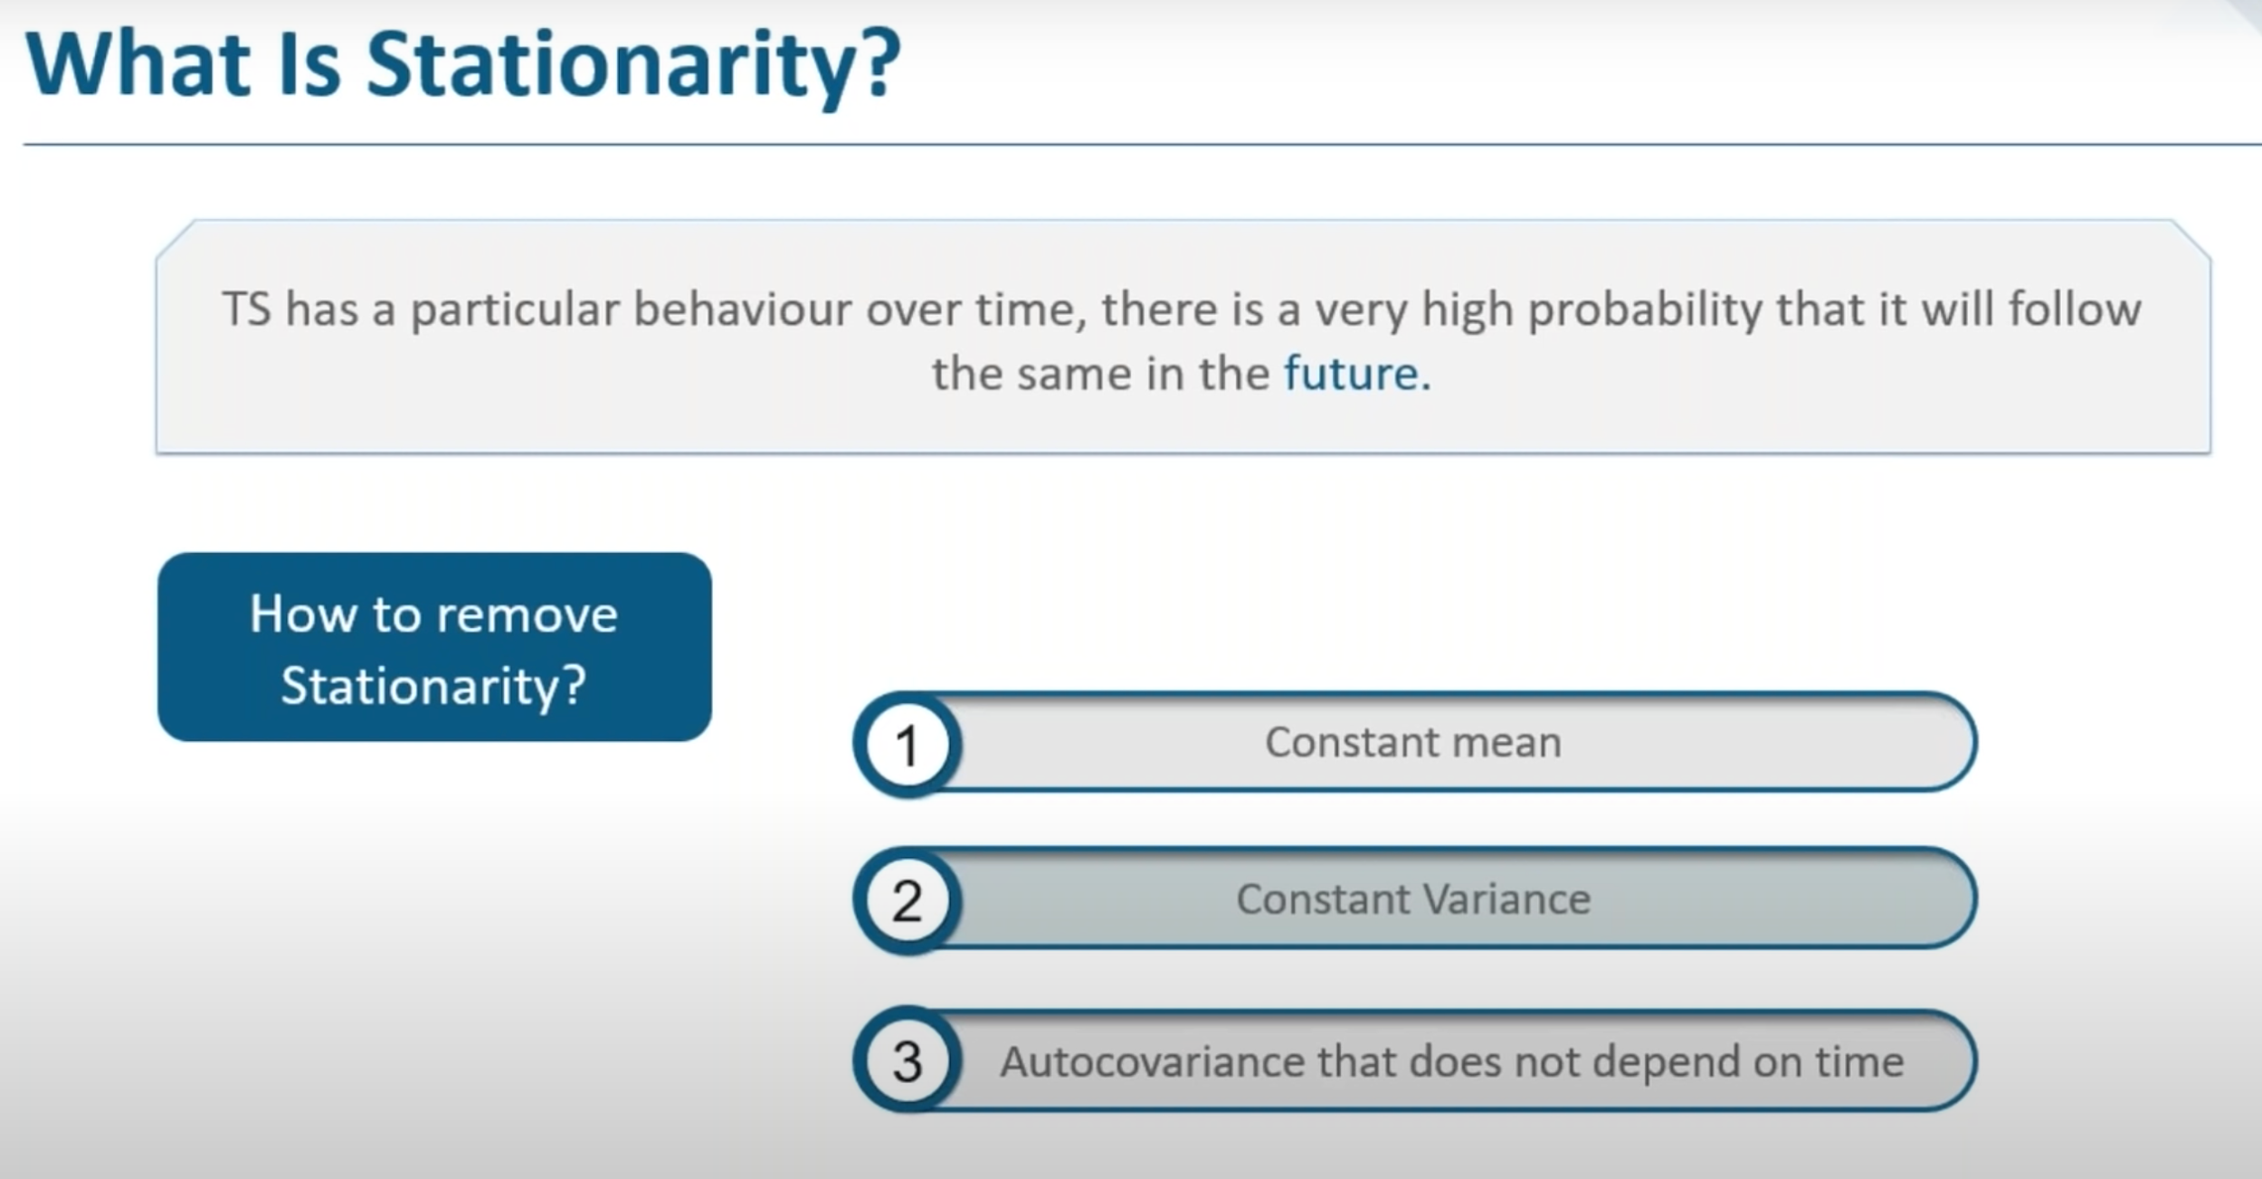

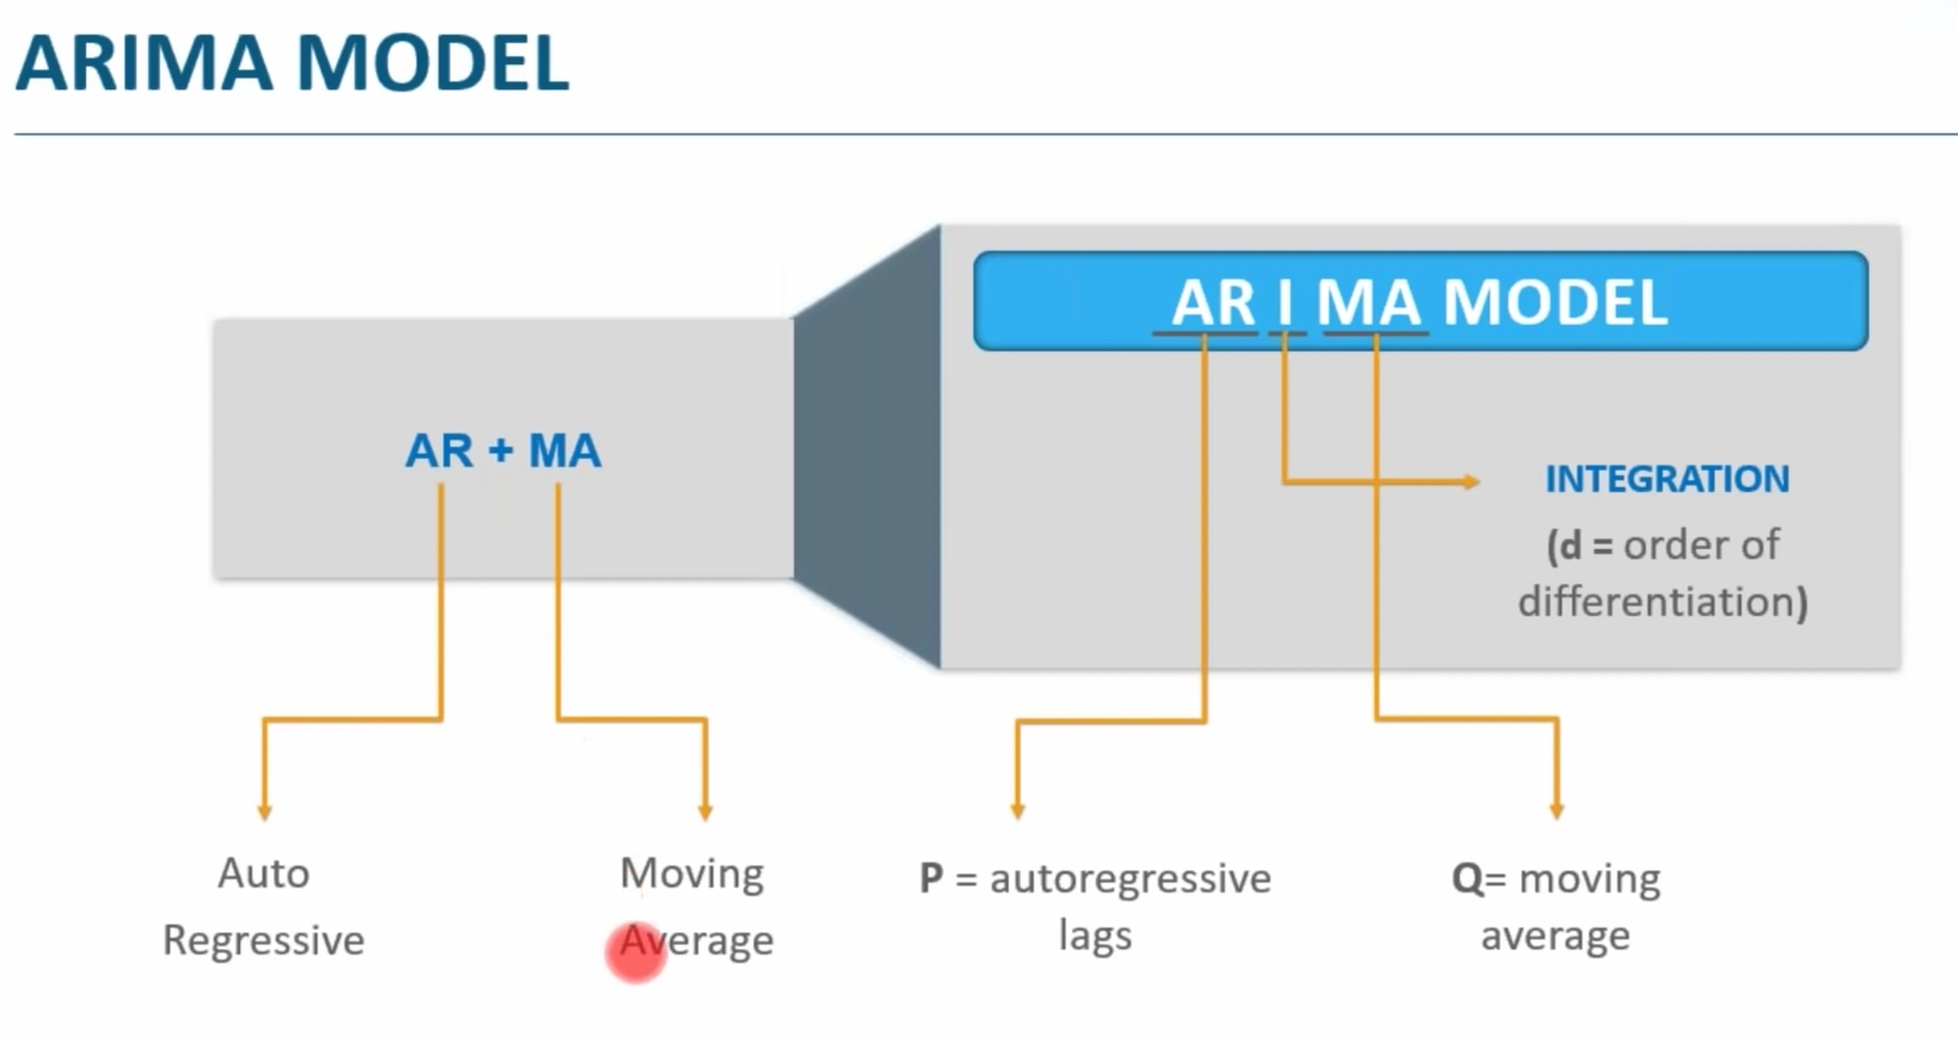

Not stationary data, conclusion reached by the non constant average (compare 1949 average with 1960 average). Graph below.

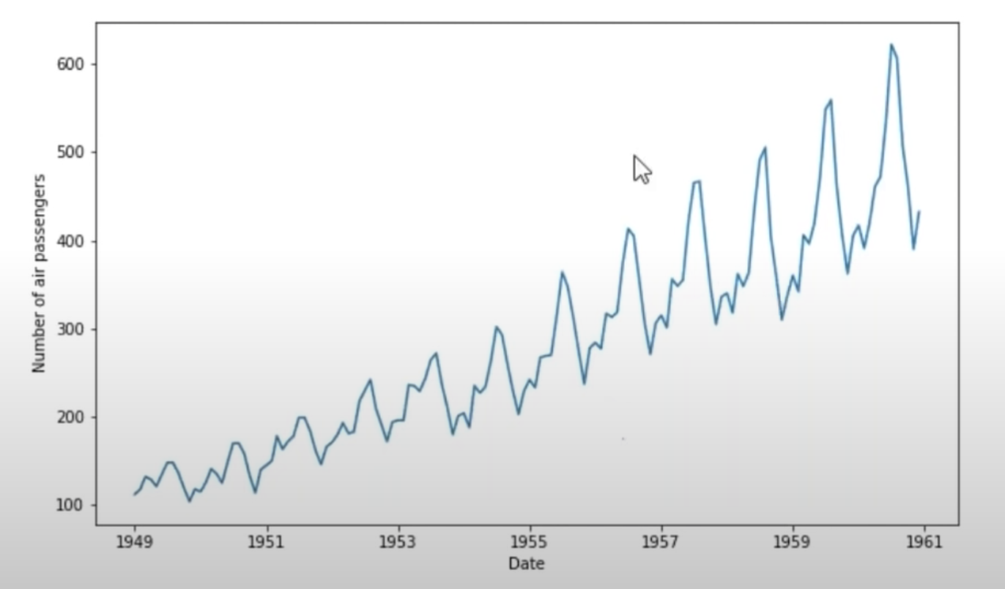

To be even more explicit, use the rolling average and standard deviation metrics.

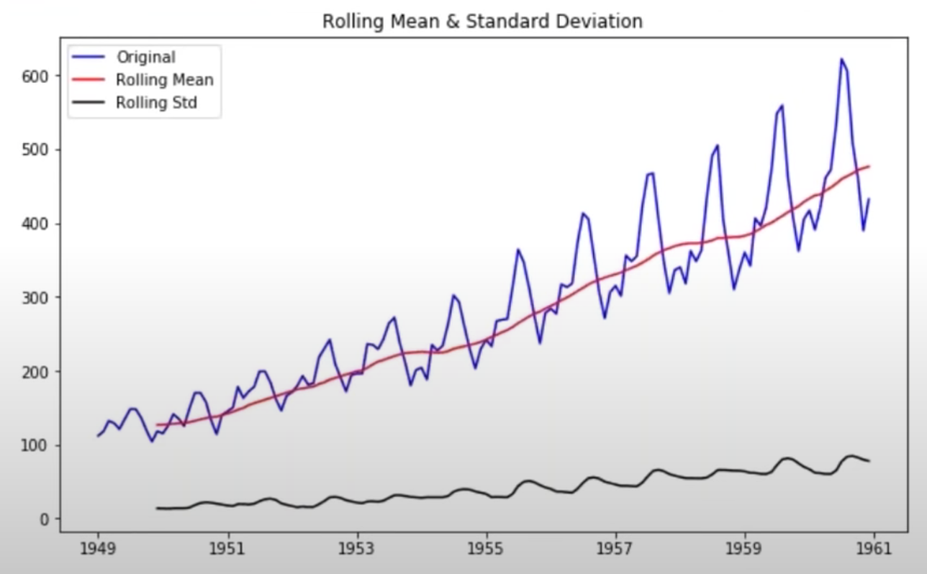

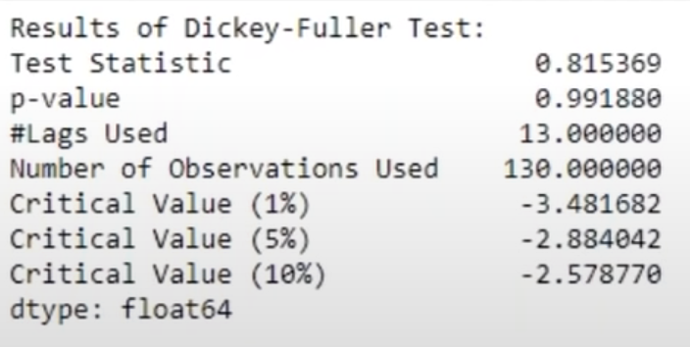

After transformation (log and subtracting the moving average over the log), we have:  
  
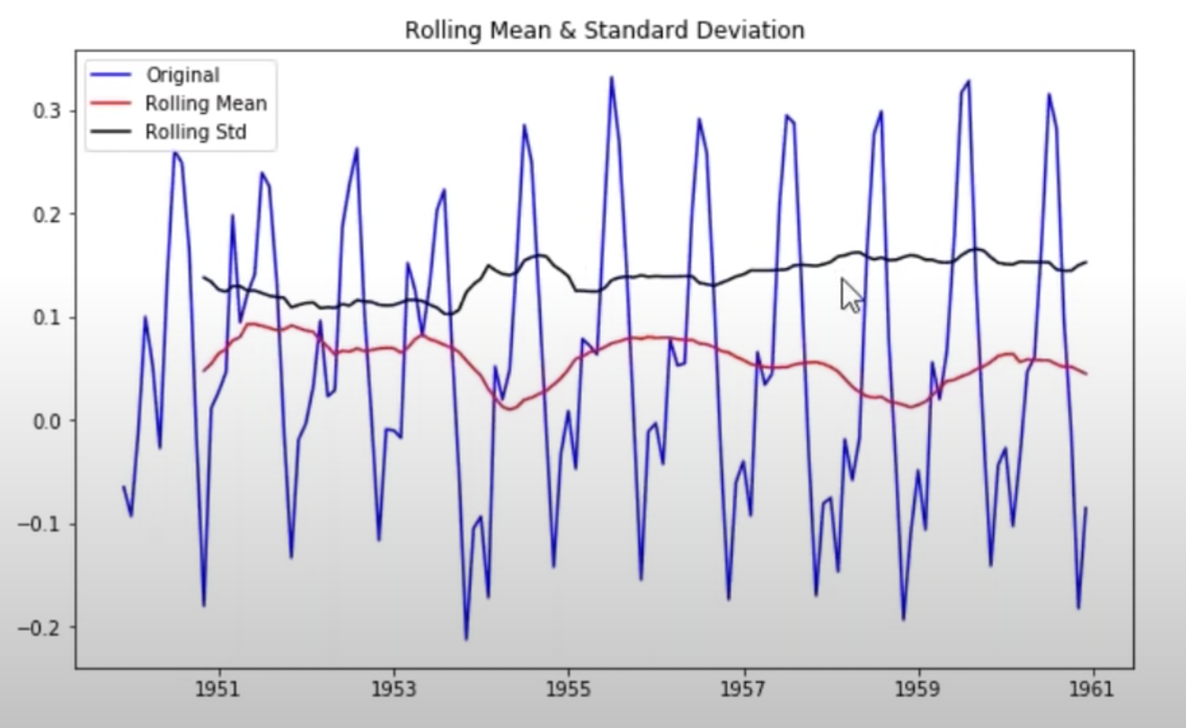

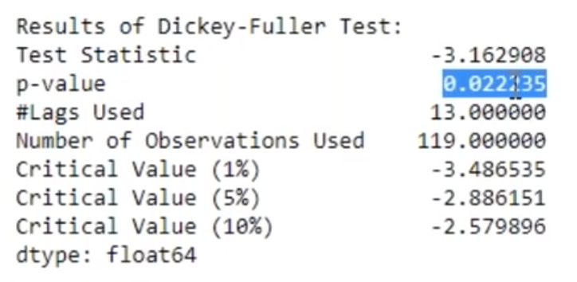

**Training of the ARIMA model**

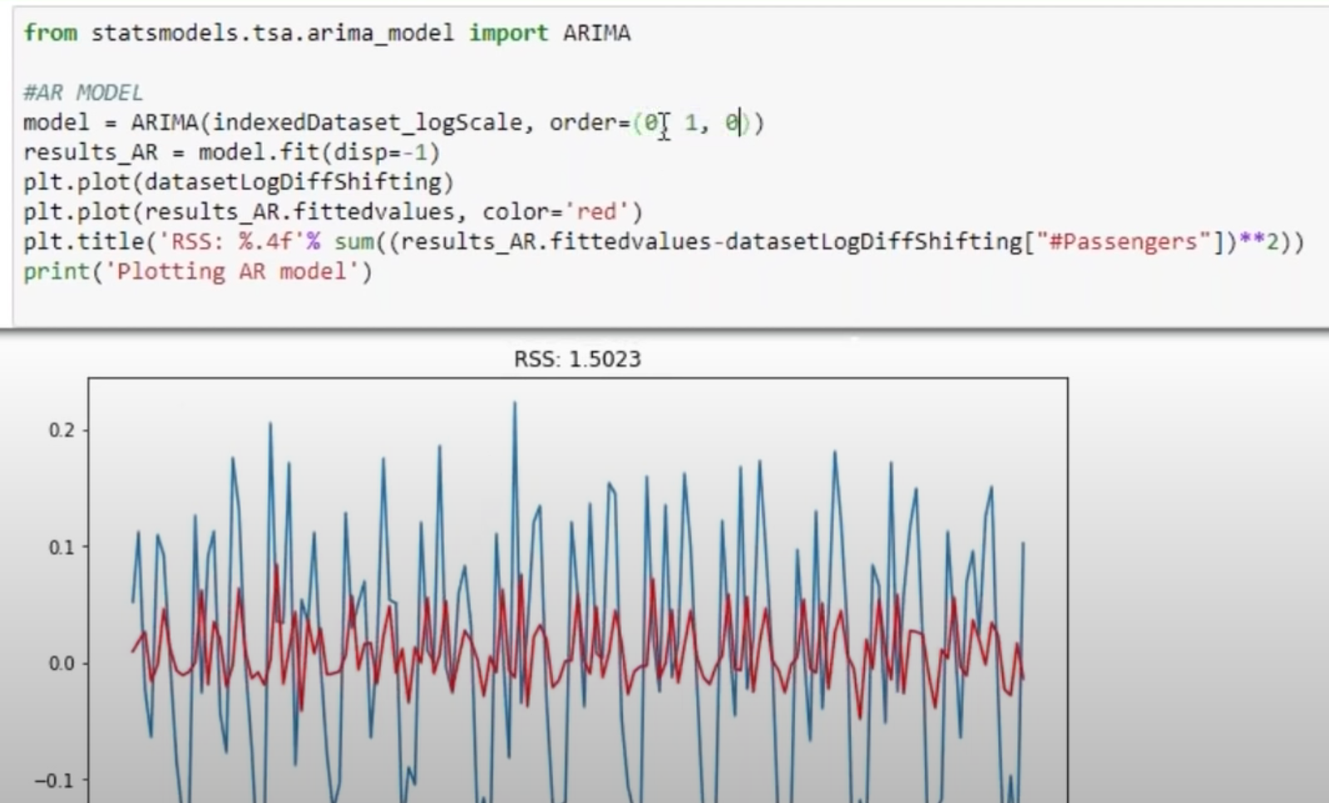

Then prediction for the next 10 years (120 months).

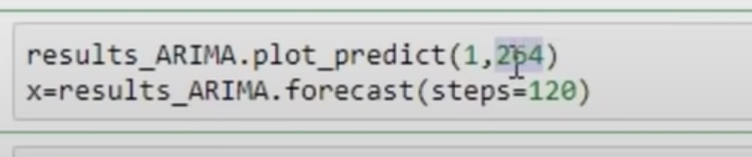

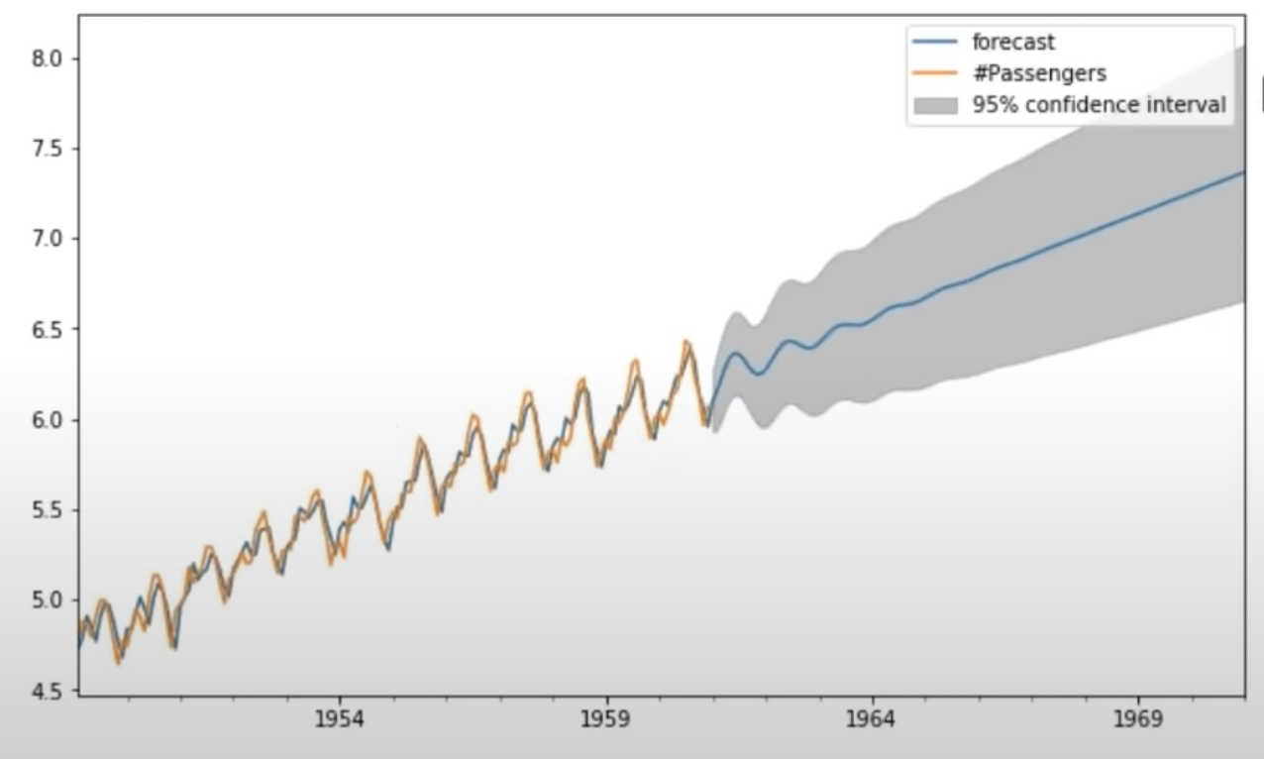

**Introduction to Forecasting in Machine Learning and Deep Learning**

**InfoQ** channel

<https://www.youtube.com/watch?v=bn8rVBuIcFg>

